Transit AS

🌐 What Is Transit AS?
# Source: AI Source: Provided by: [Data Path: Persons Table -> ID Column: 1, Name_En Column: Motasem Essam] -> From: [ChatGPT] on [1/16/2026]
A Transit AS is an Autonomous System that forwards traffic that neither originates from nor is destined to itself — it simply passes traffic between other networks.
In other words, it acts as a middleman in the internet routing path. These are usually ISPs or backbone providers that offer transit services to other ASes.

🧠 Simple Definition:
# Source: AI Source: Provided by: [Data Path: Persons Table -> ID Column: 1, Name_En Column: Motasem Essam] -> From: [ChatGPT] on [1/16/2026]
A Transit AS is a network that carries traffic between other ASes. It helps smaller networks reach the broader internet by relaying their data.

🖼️ Real-World Analogy:
# Source: AI Source: Provided by: [Data Path: Persons Table -> ID Column: 1, Name_En Column: Motasem Essam] -> From: [ChatGPT] on [1/16/2026]
Think of a Transit AS like an airport hub: passengers (data) land there but don’t stay — they’re simply transferred to another flight (network).

🔁 Example BGP AS Path:
# Source: AI Source: Provided by: [Data Path: Persons Table -> ID Column: 1, Name_En Column: Motasem Essam] -> From: [ChatGPT] on [1/16/2026]

AS64501 → AS3356 → AS15169

- AS3356 (Lumen) is the transit AS — it just forwards traffic between AS64501 (customer) and AS15169 (Google).

🛠️ Key Characteristics
# Source: AI Source: Provided by: [Data Path: Persons Table -> ID Column: 1, Name_En Column: Motasem Essam] -> From: [ChatGPT] on [1/16/2026]
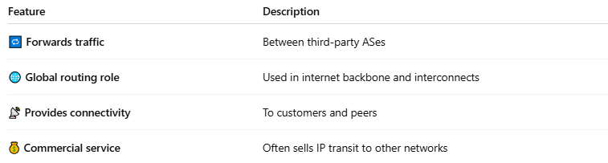
Feature | Description
🔁 Forwards traffic | Between third-party ASes
🌐 Global routing role | Used in internet backbone and interconnects
📡 Provides connectivity | To customers and peers
💰 Commercial service | Often sells IP transit to other networks

✅ Transit AS vs Stub AS vs Multihomed AS
# Source: AI Source: Provided by: [Data Path: Persons Table -> ID Column: 1, Name_En Column: Motasem Essam] -> From: [ChatGPT] on [1/16/2026]
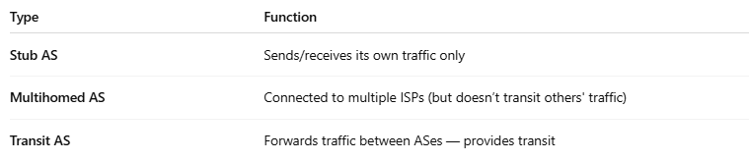
Type | Function
Stub AS | Sends/receives its own traffic only
Multihomed AS | Connected to multiple ISPs (but doesn’t transit others' traffic)
Transit AS | Forwards traffic between ASes — provides transit

🔗 Examples of Transit ASNs
# Source: AI Source: Provided by: [Data Path: Persons Table -> ID Column: 1, Name_En Column: Motasem Essam] -> From: [ChatGPT] on [1/16/2026]
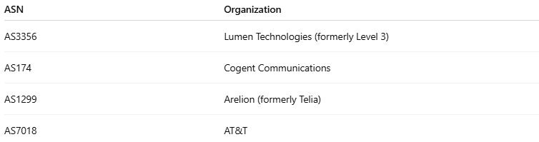
ASN | Organization
AS3356 | Lumen Technologies (formerly Level 3)
AS174 | Cogent Communications
AS1299 | Arelion (formerly Telia)
AS7018 | AT&T

✅ Summary
# Source: AI Source: Provided by: [Data Path: Persons Table -> ID Column: 1, Name_En Column: Motasem Essam] -> From: [ChatGPT] on [1/16/2026]
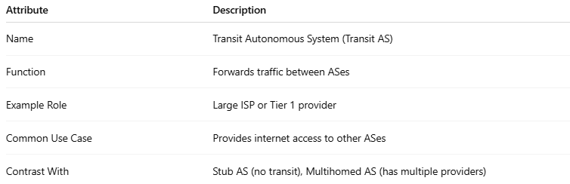
Attribute | Description
Name | Transit Autonomous System (Transit AS)
Function | Forwards traffic between ASes
Example Role | Large ISP or Tier 1 provider
Common Use Case | Provides internet access to other ASes
Contrast With | Stub AS (no transit), Multihomed AS (has multiple providers)

